Lab Assignment 3
Objective: To create simple Network Topologies Using Cisco Packet Tracer.

Q1. Connect one PC with another PC.
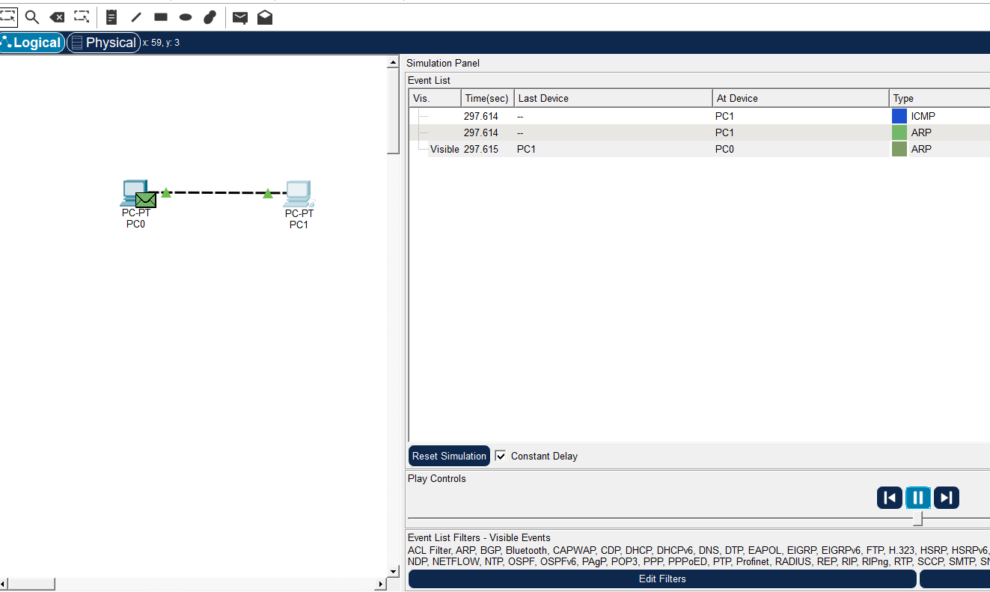

Q2. Connect a PC with Router Ethernet port.
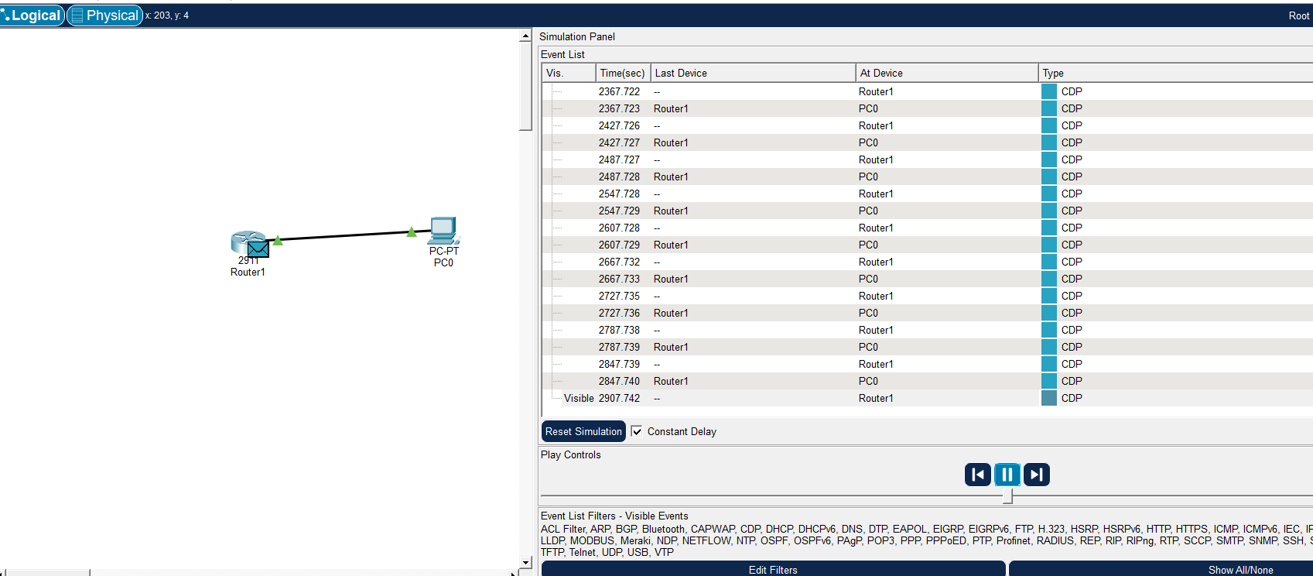

Q3. Create a network of 2 PCs.
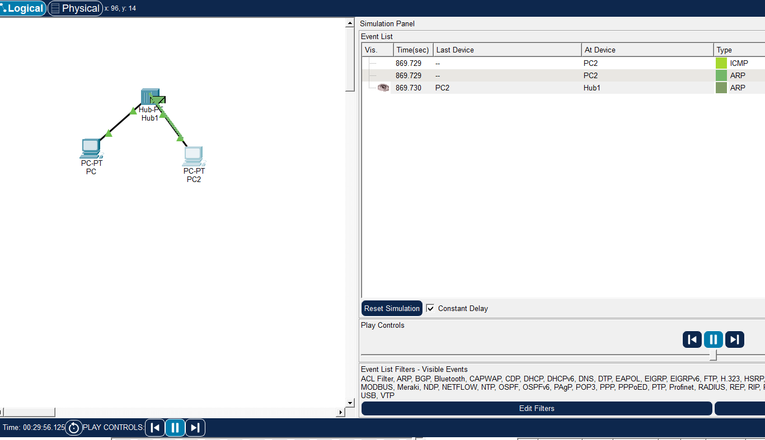

Q4. Connect 2 PCs with a Switch.
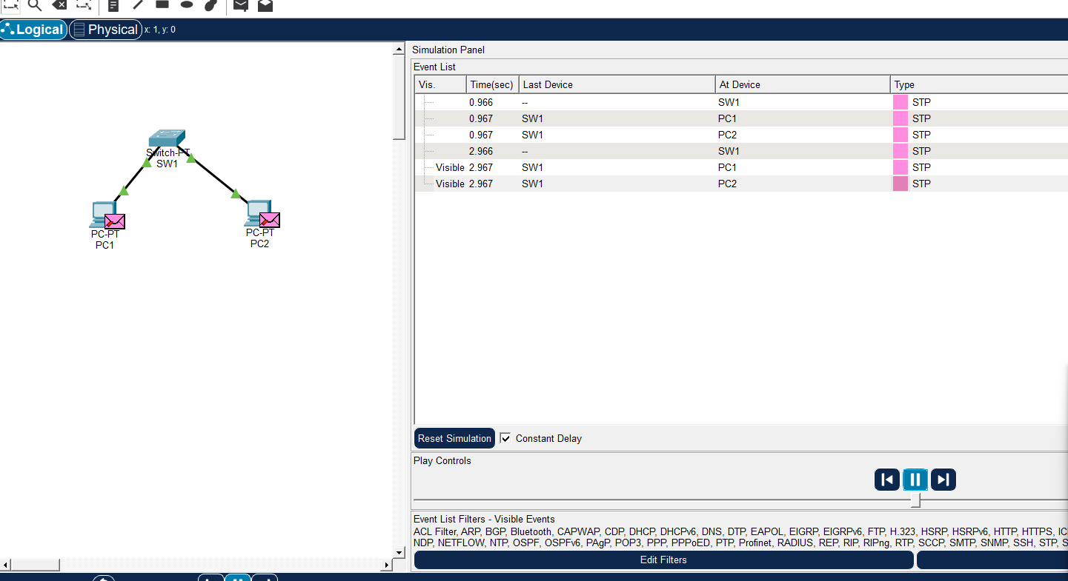

Q5. Create BUS topologies.
(a).
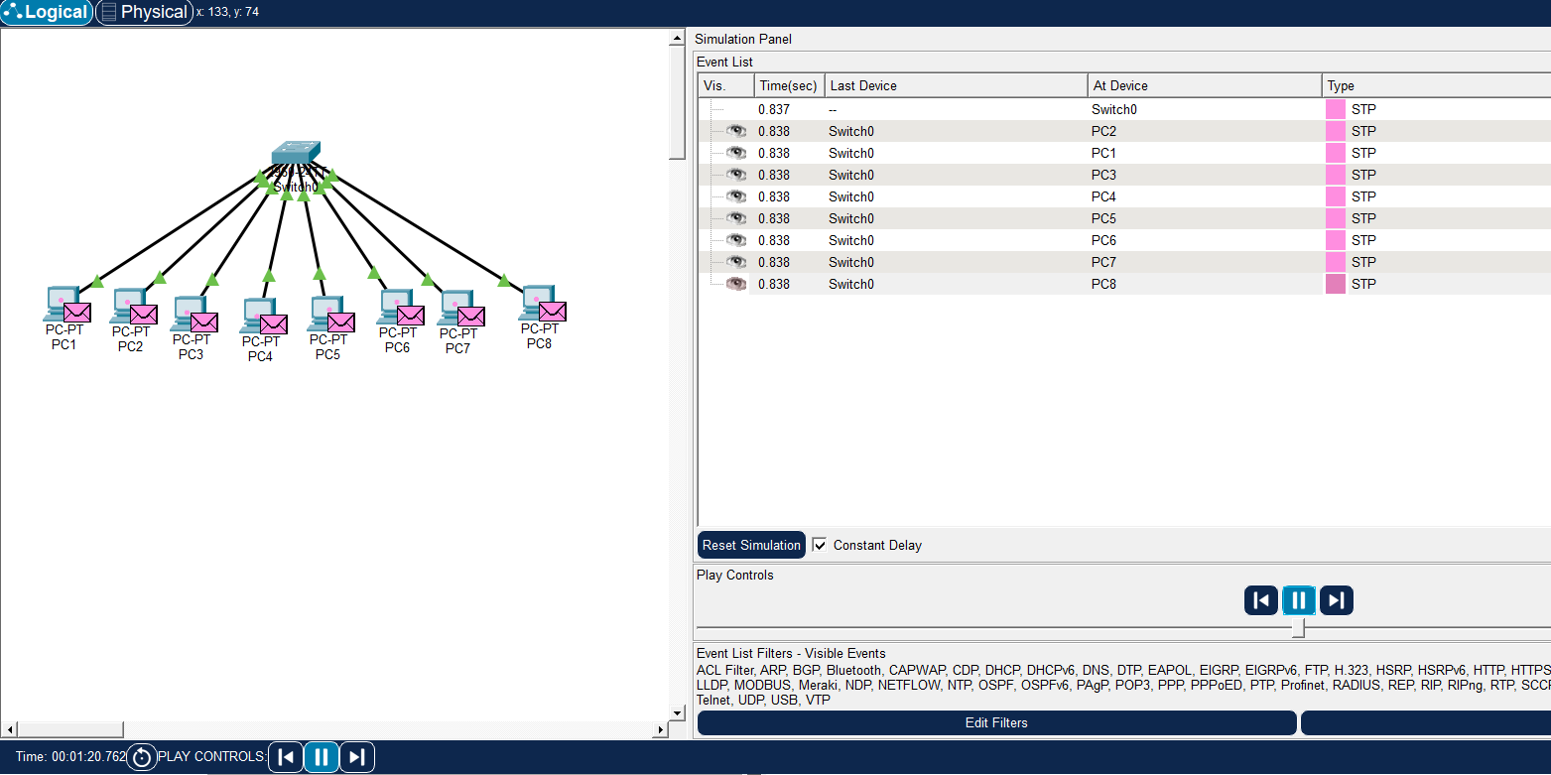
(b).
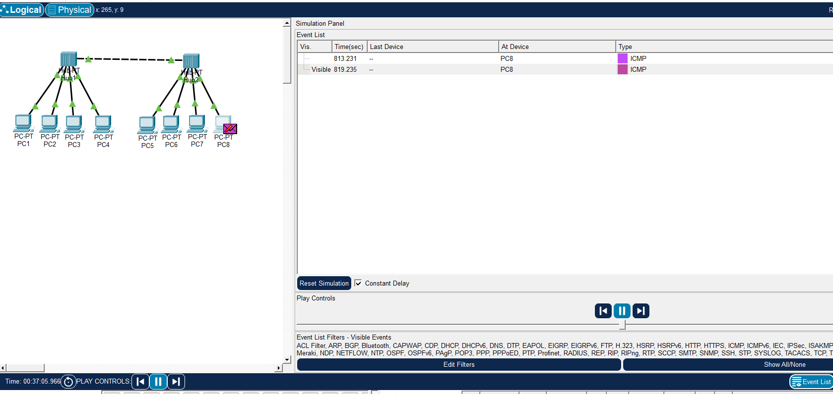

Q6. Create the Ring Topology.
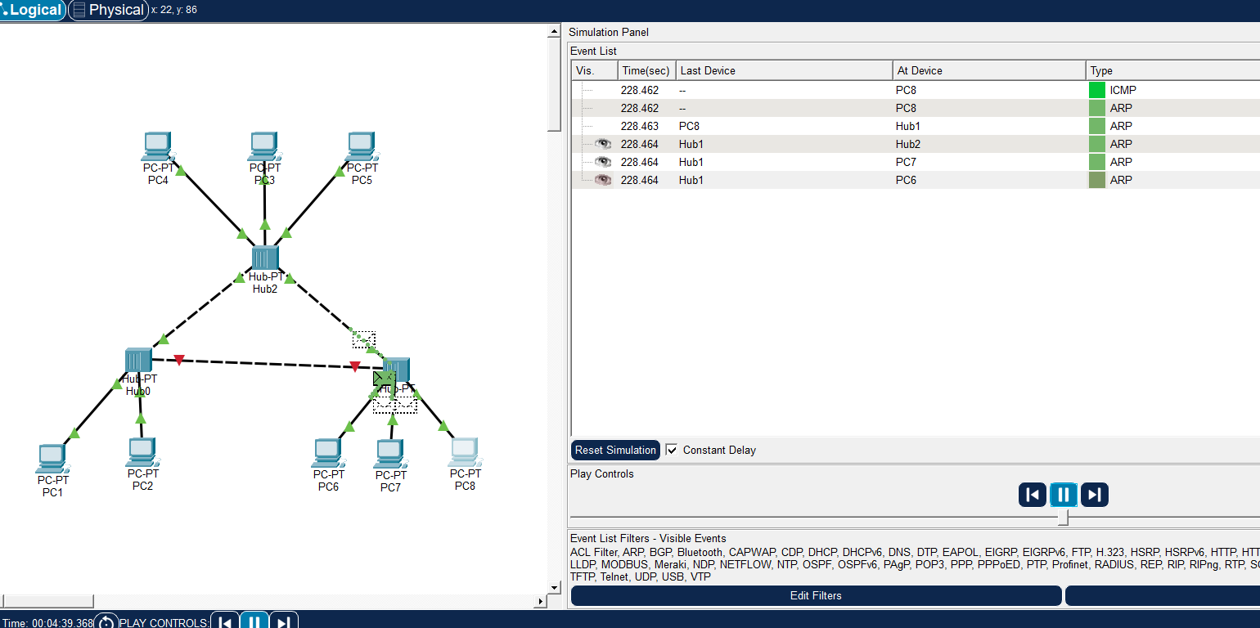

Q7. Create the Ring Topology.
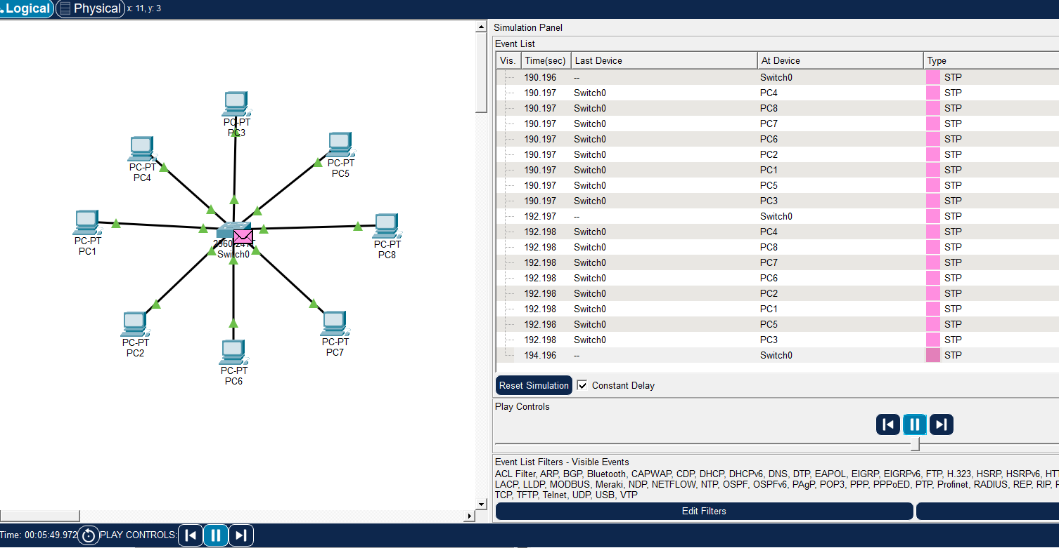

Q8. Create the Tree Topology.
